Step 04: E-R diagram of these Entity sets and Relationship Sets is given below:

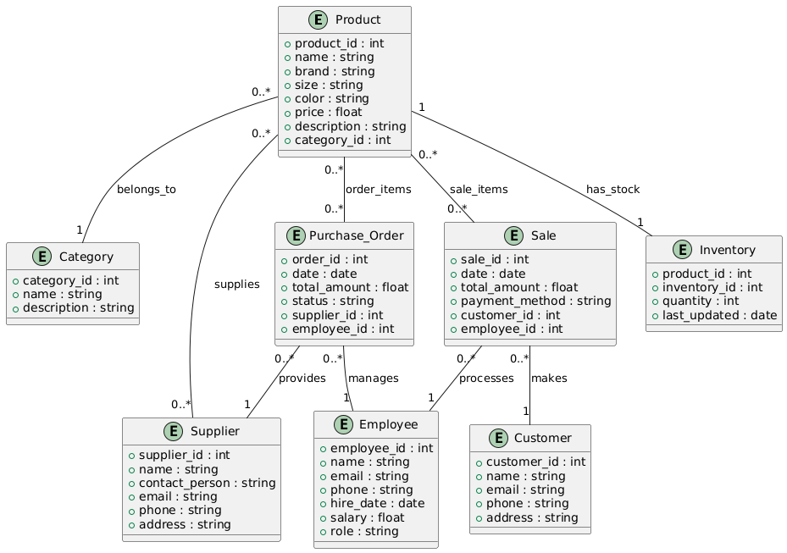

Step 05: Notation:

• Entity: Rectangles • Relationship: Mentioned no the line • Cardinalities: 1: 1 - one to one | 1: 0..\* - one to many | 0..\*: 0..\* - many to many